California Land Stewardship Institute
550 Gateway Drive Suite 108
Napa, CA. 94558
707 253 1226
info@fishfriendlyFarming.org
Fish Friendly Farming sign order form

Signs can only be displayed on certified sites. Signs are 18" x24" baked enamel on metal and have 2 holes at the top. They look like this:

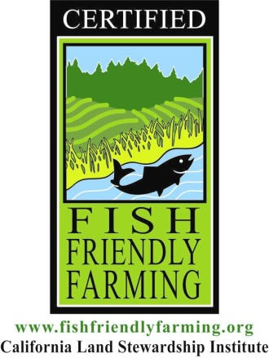

Site Name__________________

Contact Person with email and phone number_______________________

___________________ One-sided signs

____________________Two- sided signs

One sided signs are $110.00 each
Two-sided signs are $133.00 each
Shipping of signs is an additional charge.

TOTAL FEE________________

Please send a check to: California Land Stewardship Institute at the address above.

Contact Laurel Marcus or Cathy McDaniel at the number /email above if you have questions.

