California Land Stewardship Institute
550 Gateway Drive Suite 108
Napa, CA. 94558
707 253 1226
info@fishfriendlyFarming.org
Fish Friendly Farming/napa green sign order form

Signs can only be displayed on certified sites. Signs are 18" x24" baked enamel on metal and have 2 holes at the top. There are two different types:

FFF FFF/NG
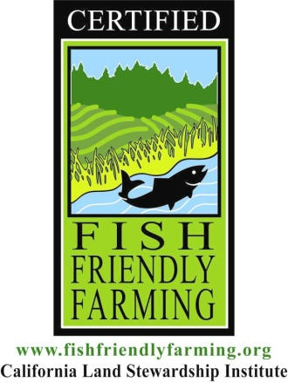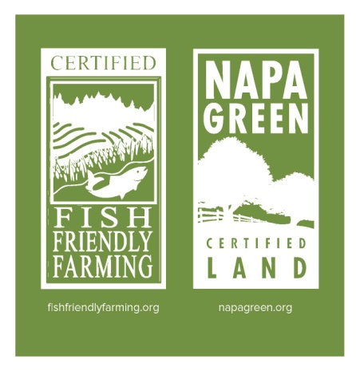

Fish Friendly Farming logo only Fish Friendly Farming and Napa Green
One sided signs are $110.00 each One sided signs are $110.00 each
Two-sided signs are $133.00 each Two-sided signs are $133.00 each

Site Name__________________

Contact Person with email and phone number__________________

__________________ One-sided signs
__________________ Which type FFF or FFF/NG

__________________ Two- sided signs
__________________ Which type FFF or FFF/NG

TOTAL FEE__________________

Please send a check to: California Land Stewardship Institute at the address above.
Contact Laurel Marcus or Cathy McDaniel at the number/email above if you have questions.

